Project Design Phase-II
AI FitTrack – Solution Requirements (Functional & Non-Functional)
Date | 24 September 2026
Team ID | AI-FITTRACK-TEAM
Project Name | AI FitTrack – AI-Powered Fitness Tracking System
Maximum Marks | 4 Marks
Functional Requirements:
Following are the functional requirements of the AI FitTrack solution.
FR No. | Functional Requirement (Epic) | Sub Requirement (Story / Sub-Task)
FR-1 | User Registration & Login | Register and authenticate using email/password; return JWT on successful login.
FR-2 | Profile Management | View and update name, age, height, weight, fitness goal and experience.
FR-3 | Workout Create | Create a workout with name, category, duration, calories and date.
FR-4 | Workout Read | List, paginate, filter and retrieve workouts belonging to the authenticated user.
FR-5 | Workout Search | Search workout name and/or category.
FR-6 | Workout Update/Delete | Modify or delete an owned workout record.
FR-7 | Dashboard Analytics | Return totals, average duration, streak, categories, weekly and recent activity.
FR-8 | AI Recommendation | Generate personalized workout recommendations from profile inputs.
FR-9 | AI Fitness Insights | Generate insights from workout summary metrics.
FR-10 | React Client | Provide a browser interface consuming the REST APIs.
Non-functional Requirements:
Following are the non-functional requirements of the AI FitTrack solution.
FR No. | Non-Functional Requirement | Description
NFR-1 | Usability | Clear React flows, validation messages and consistent API responses.
NFR-2 | Security | JWT protection, bcrypt password hashing, environment secrets and secure headers.
NFR-3 | Reliability | Centralized error handling and health endpoint for operational checks.
NFR-4 | Performance | Pagination, filters and focused queries reduce unnecessary data transfer.
NFR-5 | Availability | MongoDB Atlas provides managed database connectivity; API exposes health status.
NFR-6 | Scalability | Layered API and separate client allow independent evolution and deployment.
NFR-7 | Maintainability | Routes, controllers, services, models and middleware are separated.
NFR-8 | Observability | Request logging and controlled error responses assist troubleshooting.
API Contract Requirements
Public endpoints: GET /api/health, POST /api/auth/register and POST /api/auth/login. Protected endpoints include profile, workout, dashboard and AI routes and require Authorization: Bearer <JWT>.
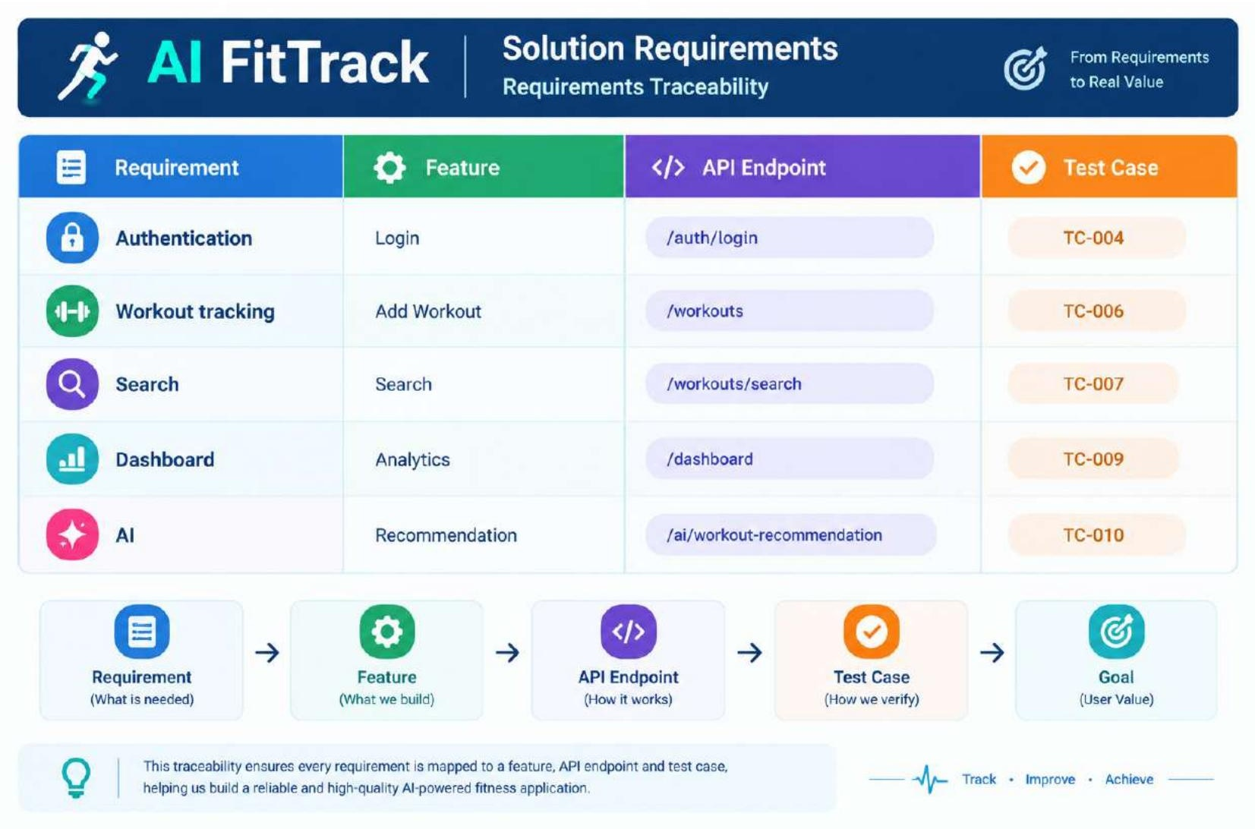
Acceptance Summary
• Every functional requirement has at least one Thunder Client request or React UI flow.
• Every protected requirement is tested with a valid JWT and a missing/invalid JWT scenario.
• AI requirements are marked complete only when the configured Google AI project can generate content.

